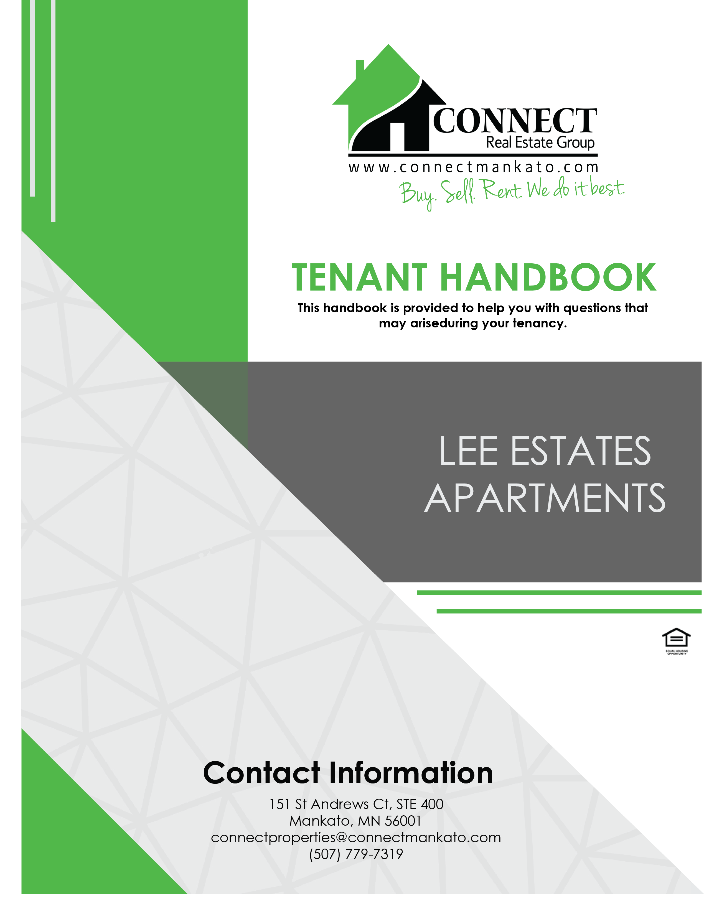
Table of Contents
This handbook is provided to help you with questions that may arise during your tenancy.

Table of Contents…………………………………………………………………………………………. Page 2
Contact Page………………………………………………………………………………………………… Page 3
Section One: MOVE IN
Address................................................................................................. Page 4
Utilities.................................................................................................. Page 4
Payment of Rent.................................................................................... Page 5
Move In Inspection................................................................................ Page 5
Section Two: THE TENACY
Maintenance/Repairs............................................................................ Page 6
Lawn Care/Snow Removal...................................................................... Page 6
Smoke Detectors ETC............................................................................. Page 6-7
Disorderly Townhomes ............................................................................ Page 7
Vehicle Parking...................................................................................... Page 7
Smoking................................................................................................
Firearms................................................................................................ Page 7
Windows & Screens............................................................................... Page 7
Vacuuming............................................................................................ Page 8
Guests................................................................................................... Page 8
Alterations to Unit................................................................................. Page 8
Apartment Wall Policy.................................................................. Page 8
Heat...................................................................................................... Page 8
Lockouts……………………………………………………………………………………………. Page 9
Policy on Disturbances/Security............................................................. Page 9
Section Three: MOVE OUT
Move Out.............................................................................................. Page 10
Move Out Condition…………………………………………………………………………….. Page 10-11
Return of Deposit.................................................................................. Page 11
Fees.................................................................................................. Page 11
Repairs.................................................................................................. Page 11-12

Office Phone: 507-345-6518
connectproperties@connectmankato.com
www.rentwithconnect.com

Property Manager (Kellie): 507-399-9889
Property Manager (Christa): 507-327-6300
Property Manager (Brandon):507-340-6999
After Hours Non-Emergency: 507-345-6518
After Hours Emergency: 507-327-6300
Emergency: 911

Connect Real Estate Phone: 507-779-7319

Office Hours:
Connect Real Estate Group: M-F 8-5pm

Section One
MOVING IN

ADDRESS:

___________________________________________North Mankato, MN 56003

Change your address at the Post Office: 100 Le Sueur Ave, Eagle Lake, MN 56024 or at usps.com (select “change your address” under “manage your mail”)

UTILITIES:
Please call the utility companies and put in your name AT THE TIME of move in.
IF YOU FAIL TO CHANGE THE UTILITIES INTO YOUR NAME, YOU WILL BE CHARGED A $25 FOR EACH OCCURANCE THE OFFICE RECIEVES YOUR BILL.

Electric:

Cable/Internet:

Tenants are responsible to pay electric & cable and telephone.
All questions concerning billing and usage after move-in should be directed to service provider.

TRASH: IT IS YOUR RESPONSBILITY to dispose of any car parts, TVs, TIRES, electronics, or anything else that cannot be accepted by the refuse hauler. ALL TRASH MUST BE PLACED & FIT into the DUMSPTERS/CONTAINERS PROVIDED. The cost of removing any unclaimed garbage that hauler will not take will be billed to the rental unit or the whole complex. Please report to US if someone is inappropriately disposing of non-accepted items.

PAYMENT OF RENT
EACH TENANT SIGNED ON THE LEASE IS INDIVIDUALLY AND JOINTLY RESPONSIBLE FOR PAYING THE FULL AMOUNT OF RENT AND ANY OTHER MONEY OWED TO MANAGEMENT.

ALL RENT IS DUE FIRST DAY OF EACH MONTH!

- Payments NOT RECEIVED BY 5pm on the 5TH of EACH MONTH will have an 8% service charge added to their account.
- If all rent is NOT received by the 10th of the month, Management may begin the eviction process for ALL tenants, and ALL tenants will be responsible for ALL past due rent, late fees, court costs and reasonable attorney’s fees.
- There is a $30 charge for all RETURNED/NSF checks. ALL future payments must be in CASH or CERTIFIED Funds only.
- CASH, CHECK, MONEY ORDER, CASHIER’S CHECK, or BILL PAY CHECKS
  - To ensure checks are processed, please make checks payable to:Lee Estates

- CASH payments must be for exact amount; change will not be issued. Credit will be issued for overpayment of amount on the account.
- Payments may be dropped at the designated drop boxes. There is a drop box located at 311 E. Roosevelt Circle (Woodside Apartments), given to office staff during office hours, or dropped at Connect Real Estate Group’s Office location.
- PLEASE INCLUDE YOUR UNIT # on the check to ensure we apply your payment to the correct account.

MOVE IN INSPECTION
- Please inspect your unit thoroughly at move in. Tenant is responsible for filling out move in walk through documentation. Please note items that are damaged, need repair, etc. RETURN this to the office within 3 days of your move in date for it to be valid. You will be charged for undocumented damages beyond normal wear & tear to your unit at the end of your lease.

Section Two
THE TENACY

MAINTENANCE/REPAIRS:
Non-emergency requests (those not posing immediate damage to property or tenants) must be submitted ONLINE, or by calling our office at 507.345.6518.
Online: www.rentwithconnect.com Click on “Maintenance Tab”

**EMERGENCY REQUESTS (toilet overflowing, water leaking, other items causing immediate damage) should be reported to management IMMEDIATELY at 507-327-6300.

** KEEP at least one (1) plunger in your unit at all times. If maintenance staff must remove a foreign object from your toilet, sink, tub, you will be CHARGED accordingly.
**In an emergency you may need to shut off your electrical power. LEARN the location of your breakers.

LAWN CARE/SNOW REMOVAL
- Management will provide lawn care and snow removal for all units. Tenants are responsible for maintaining the yard free of garbage, debris and waster. Tenants must cooperate with snow removal procedures, which may mean moving cars to another parking lot/area.

SMOKE DETECTORS/CARBON MONOXIDE DETECTORS/FIRE EXTINGUISHERS
Each rental unit is equipped with smoke detectors, fire extinguishers, and carbon monoxide detectors. It is your responsibility to make sure they are hooked up and functioning. If a detector is determined inoperative, you must contact management immediately. We will confirm units are working at move in/move out and if they are missing or damaged you will be charged for replacements.

- City inspections will occur in random units on occasion and if they note/fine the building for removal or damage of the detectors, the fine will be added to your account.

- IT IS ILLEGAL TO DISCONNECT SMOKE DECTOORS/CARBON MONOXIDE DECTORS. YOUR & YOUR ROOMMATES MAY BE CHARGED WITH A MISDEMEANOR FOR DISCONNECTING OR DISABLING THEM, as well as a $250 FINE ISSUED TO YOUR UNIT!
- Do not tamper with or remove the fire extinguisher. In the event it is used in an emergency, please contact management to receive a new one.

DISORDERLY APARTMENT
At certain times management may choose to inspect your rental unit for upkeep and condition. If it is determined that your unit is being abused beyond normal wear and tear you will receive a notice for a disorderly unit. It will be your responsibility to clean, repair, replace items as outlined in this notice. This included pest removal costs. Failure to do so will result in violation of the lease and tenant will incur a fine/eviction.

VEHICLE PARKING
- Tenants should use the off street parking at all times.
- All motorcycles must have a kickstand pad and will be assessed a $150 fee per incident.
- If parking a trailer, boat, or other large oversized vehicle. Please be courteous and try to minimize the number of spots used up. DO NOT block the sidewalk or aisles. This may result in having to move your vehicle/trailer or towing.

SMOKING
All buildings & attachments are smoke free. Smoking indoors is prohibited. It is illegal per MN State law, and will result in a violation of your lease. Any violations will result up to a $200 FINE and a LEASE VIOLATION! ALL tenants must smoke outside and dispose of cigarette butts properly.

FIREARMS
- Connect Property Management does allow the storage of firearms in resident’s apartments. Residents must have appropriate permit & licenses. Firearms MUST be LOCKED or SECURE when stored in rental units or garages.

WINDOWS & SCREENS
Screens are difficult to remove correctly and can be easily damaged. If you damage the screens and they need to be replaced, it will be billed to your unit. Please avoid hitting them with objects, furniture, etc. Tenants are prohibited from removing the screens except for in case of emergency evacuation.

VACCUMING
If you do not own a vacuum cleaner, please procure one. Regular vacuuming and cleaning of your flooring will greatly deter excessive wear and tear. If you stain your carpet, please let management know, and try to clean. It may be best to shampoo the carpets as well.
- CARPETS WILL PROFESSIONALLY CLEANED prior to move out – as stated in security deposit notice & lease. Management will arrange and the cost will be deducted from your deposit.

GUESTS
- Please limit the number of guest to your home, and immediately ask guests to leave if they become unruly. You are responsible for your guest’s actions and if complaints or damaged is received as a result of your guests, you will be held responsible.
  - After 2 weeks (14 consecutive days) guests are considered to be residents and MUST be added to the lease. Units with unauthorized occupants will be charged $250 per person PER week.

ALTERATIONS TO UNIT
- DO NOT PAINT OR WALLPAPER, MAKE ANY STRUCTRUAL OR FLOORING ALTERATIONS.
- DO NOT REMOVE ANY FIXTURES supplied by management.

APARTMENT WALL POLICY
RESIDENT is allowed to hang items with nails only. RESIDENT will not patch their own nail holes prior to move out.
- Sheetrock Anchors are NOT allowed on any walls. If RESIDENT VIOLATES THIS POLICY, there is a $25 charge PER hole will be assessed at move out.
- TV Mounts – RESIDENT will be charged $100 PER MOUNT at move out for wall damage.
- Any additional wire shelving or other shelves mounted by RESIDENT MUST BE LEFT ON WALLS AT MOVE OUT, or there will be a charge of $100 PER SHELF.

HEAT
Tenants are responsible for keeping the heat on to prevent freezing of the pipes. Please keep the unit at a minimum of 65 degrees in the winter, especially when gone. Please ensure windows are fully closed & locked to minimize heat loss.
- Damages due to frozen pipes can amount to thousands of dollars and resident will be responsible for any costs of repairs deemed as a result of their actions.
- Please alert management IMMEDIATELY if you feel your furnace is NOT functioning properly or your Carbon Monoxide detectors goes off.

LOCKOUTS
Management will try to accommodate and assist during a lock out. Apartment doors are deadbolts, locked from outside, so it should be nearly impossible to get locked out.
- Tenant will be charged $50 for a lock out assistance. Payment is due immediately. Failure to remit payment will result in loss of lock out assistance.

POLICY ON DISTURBANCES/SECURITY
Please contact the office during business hours or the after hours phone line for non-life threatening concerns, such as noise disturbances.
- Contact 911 for life threatening concerns, such as an intruder, violence or medical issues.
- Connect Property Management reserves the right to enforce a fine and/or take further action against units responsible for excessive disturbance calls.
- The City of Mankato/North Mankato has a policy concerning disturbance complaints. Disturbances can be noise, party, animal, or exterior related. Any rental unit receiving two (2) complaints or strikes in a twelve-month period brings rental license under review for revocation or suspension. It is critical that you respect your neighbors use and enjoyment of their property. Tenants are responsible for the actions of your guests. The following fines will be charged for violation of your lease agreement if a strike is issues against the property:
  - 1st strike: one-half (1/2) month’s rent plus possible eviction
  - 2nd strike: one (1) month’s rent plus possible eviction
  - 3rd strike: Immediate eviction and responsible for the rent due for the remainder of the lease agreement and/or license suspension period, whichever is greater

IF THE CITY REVOKES OR SUSPENDS THE LICENSE FOR THE BUILDING AND/OR YOU ARE EVICTED; YOU WIL STILL BE RESPONSIBLE FOR THE RENT DUE FOR THE REMAINDER OF THE LEASE AGREEMENT AND THE LOSS OF INCOME RESULTING FROM REVOKED OR SUSPENDED RENTAL LICENSE.

Section Three
MOVING OUT

MOVE OUT
- All keys & REMOTES issued to you must be returned at move out. There is an automatic deduction of $150 from deposit if all keys are not returned on or before lease end date for required lock change. Any missing fobs will be $25 each. Missing remotes are $80 each.
- Each tenant must provide a forwarding address and return keys!
- You must be out of your unit by NOON according to your lease end date. Items must be removed and cleaning completed by this time, and a walk through completed with staff. Anything still in the unit or not cleaned will be charged $50 an hour to remove/clean.
- Tenants must call all utility companies to stop service. Tenant is responsible for return all cable/internet equipment to service provider.
- ALL tenants must be present at final walk through, or given written notice to management that they will not be attending and are waiving this right.

MOVE OUT CONDITION
As a rule, we are looking for your unit to be left in a rentable state with NO work necessary to get it in shape for next tenant. THIS INCLUDES, but is NOT LIMITED TO THE FOLLOWING:
  - Carpets Cleaned – Vacuumed & shampooed (receipt provided or management will arrange)
  - Hard floors Swept & Mopped
  - Kitchen appliance cleaned inside, outside, behind and underneath:
    - Refrigerator – defrost if applicable
    - Stove – hood, exhaust fan, burners
    - Oven – racks, broiler, knobs/burner
    - Dishwasher – drain cleaned, and wiped out
  - All cabinets empty and wiped inside and outside
  - Windows and sills cleaned inside. DO NOT REMOVE windows for cleaning
  - Walls, doors, woodwork
  - Kitchen and bathroom sinks/toilets/fixtures cleaned – including drains cleaned of hair and draining freely
  - Light fixtures, including bathroom exhaust fans, cleaned with working bulbs
  - Apartment Cleaning - $50 per hour
  - Blinds – clean and operational
  - Heating/Cooling vents and registers cleaned and wiped off
  - Washer and Dryer – wiped down inside and out, lint removed
  - Smoke detectors – connected and operational
  - All trash and debris removed from inside & outside of unit and disposed of properly
  - DO NOT FILL YOUR NAIL HOLES – Management will do this after move out – If there are large anchors, or excessive holes, management will deduct from your deposit for these repairs.

RETURN OF DEPOSIT
- Deposit will be returned in for the amount paid if:
- Tenants have not violated any terms of lease
- Given written 60-day notice of intent to vacate
- No damage beyond normal wear and tear
- Entire unit is cleaned
- Tenant has paid all rent, late charge and other debt owed
- All keys & remotes have been returned
- All debris, trash has been placed in disposal containers and personal property removed
- All tenants left forwarding address
- Tenant has paid off all other debts to service providers/utility companies
- A check or letter detailing charges, if any, along with all security deposit money due to you will be mailed within 21 days of the expiration of your lease.
- Questions regarding your computation must be submitted in writing, within 15 days of receipt. We will be happy to pull your file and re-check. If we have made an error, we will adjust. Due to time involved in getting answers we will only respond to those questions submitted in writing. We will answer all requests for file review in a timely manner. Please email questions to connectproperties@connectmankato.com

FEES
Apartment/Mail Key - $40
Failure to clean up animal waste - $50 for 1st, $100 for 2nd
Garbage – Cost of removal or minimum of $10 per bag
Late Rent – 8% of Rent Not Paid
Lockout - $25
Non-Sufficient Funds Check - $30
Unauthorized Pet - $800 per Pet
Authorized Pet - $400 for 1 pet
Unauthorized Resident -$250 per week, per Occupant

REPAIR
Blinds - $50 each
Burned out/Missing Light Bulbs @ Move Out - $10 each
Excessive carpet wear - $2 per yard
Carpet Replace - $21 per yard
Entry Door Repaint - $60
Entry Door Replacement - $350
Fire Extinguisher Replacement - $70
Interior Door Replacement - $175
Outlet/Switch Covers - $5 each
Repainting - $50/Hr.
Smoke/CO2 Detector Replacement - $50 each
Toilet Plunging/Drain Cleaning Due to Tenant Neglect/Negligence - $50 per incident
Unnecessary Service Calls – Cost of Visit, minimum of $50 each
Window Glass Replacement – $90 each
Screen Replacement - $55 each
Cleaning
General Cleaning - $50/Hour
Sheetrock patch/repair - $50/Hour
Carpet Shampooing – Based on unit size
Landscaping/Grass Repair - $50 per hour

